|  |  |
| --- | --- |
| **Logo_FPT_University_doc** | **MINISTRY OF EDUCATION AND TRAINING** |

|  |
| --- |
| **FPT UNIVERSITY** |
| Software User’s Manual |
| OATS |
|  |
| |  |  | | --- | --- | | **Group 6** | | | **Group Members** | Huynh Minh Tu – Team leader –  An Ngoc Anh – Team member – 60223  Bui Tuong Thi – Team member – 00721  Nguyen Duc Tan – Team member - | | **Supervisor** | Mr. Nguyen Huy Hung | | **Ext Supervisor** |  | | **Capstone Project code** | OATS | |
|  |

Ho Chi Minh City, 08/2013

**Record of Changes**

|  |  |  |  |  |
| --- | --- | --- | --- | --- |
| **Date** | **Changed Item** | **Description** | **By** | **Version** |
| 07/08/2013 | All | Create Document | AnhAN60233 | 1.0 |
| 08/08/2013 | All | Add, edit document | ThiBT00721 | 1.0 |
|  |  |  |  |  |
|  |  |  |  |  |
|  |  |  |  |  |
|  |  |  |  |  |
|  |  |  |  |  |
|  |  |  |  |  |
|  |  |  |  |  |

PART F – SOFTWARE TEST DOCUMENTATION

# I. Installation Guide

## 1. Setting up the environment at server side

### Hardware requirements:

Personal computers for developing with the minimum configuration: CPU Core 2 Duo 2.0GHz, 2GB of RAM, 120GB of hard disk, and internet.

### Software requirements: (with framework ASP.NET MVC 4)

The follow software must be installed into server machine:

Windows 7 or higher versions

IIS Express 7.5 or higher versions

Microsoft SQL Server 2012 or higher versions

## 2. Deployment at server side

### Deploy database

Open SQL Server and run OATSDB\_v0.1.sql script to create database named OATSDB, then run DataOnly\_v0.1.sql script to add necessary data.

## 3. Setting up the environment at client side

The client devices need to have one of the following browsers to launch the OATSDB websites:

* Mozilla Firefox 10.0 or higher
* Microsoft Internet Explorer 8.0 or higher
* Apple Safari 5.1 or higher
* Opera 15 or higher

# User‘s Guide

## General Guide

### 1.1 Register and Login

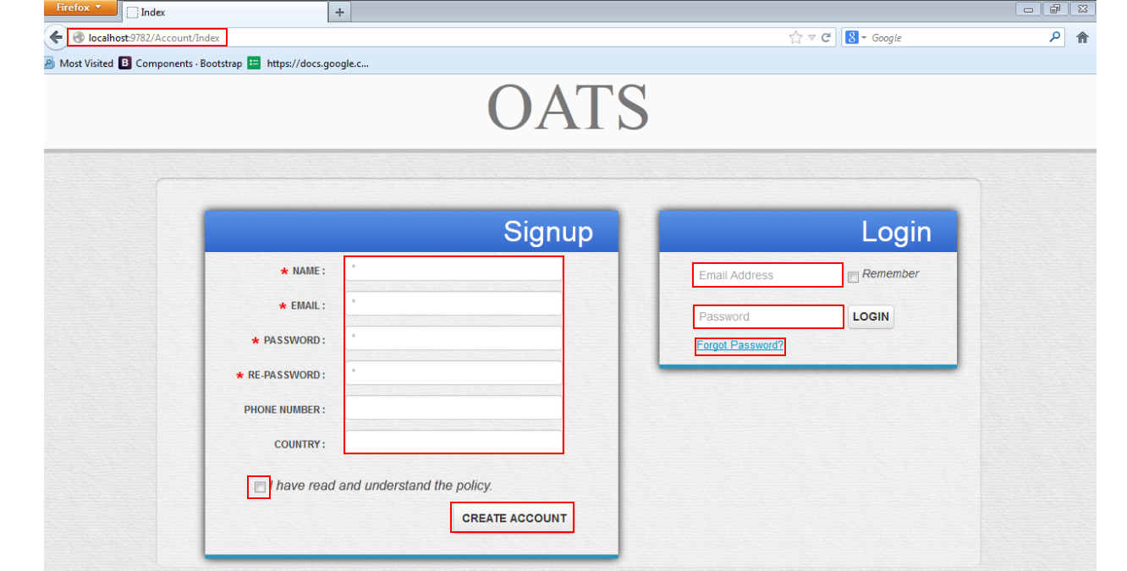

Figure : Register and Login

**Register**

Step 1: Enter the home site address

Step 2: If user want to create an account, at “Signup” board, fill following information:

+Name (required)

+Email (required)

+Password (required)

+Confirm Password (required)

+Phone Number (optional)

+Country (optional)

Step 3: Check “I have read and understand the policy” checkbox

Step 4: Click “Create Account” button

**Login**

For user have account already and want to login to site, at “login” board:

Step 1: Fill following information:

+Email (required)

+Password (required)

Step 2: Check “Remember” checkbox for remember user login later.

Step 3: Click “Login” button

Step 4: If user forgot password, Click “forgot Password” hyperlink

Enter correct email and click “Send” button, else “cancel” to return to index page.

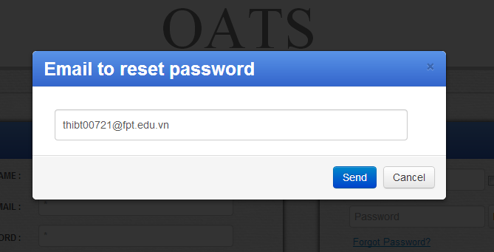

Figure : Forgot Password

## Common Guide (For both Teacher and Student Role)

### View Tests

Here user can view all tests that available in calendar or in list

**+Calendar**

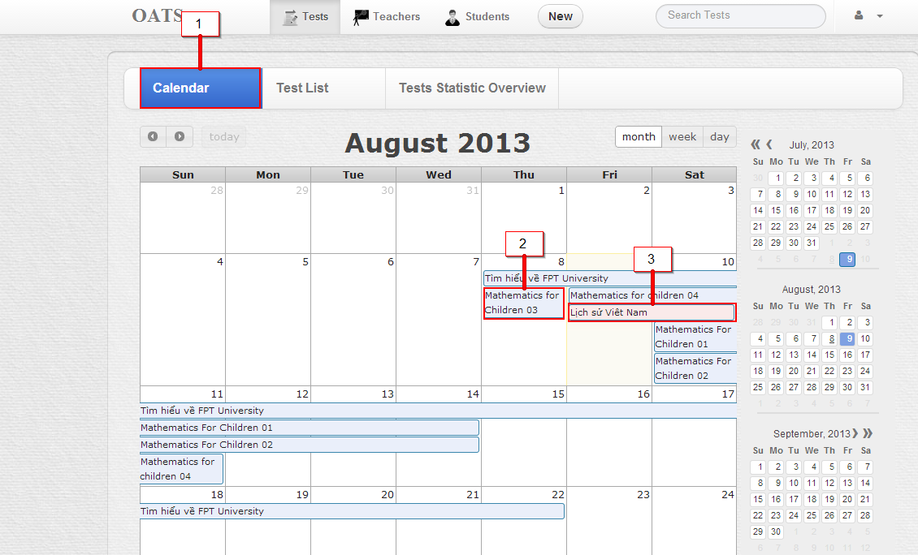

Figure : View All Tests in Calendar

Step 1: Login into system

Step 2: Click on tab “Calendar” (1)

User will see:

Test that create in “light blue” color (2)

Test that was assigned in “light red” color (3)

Notice that user can view calendar in Month, Week or Date.

**List**

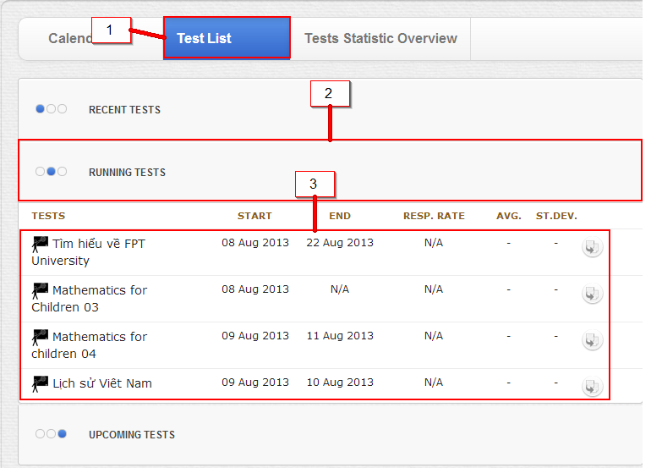

Figure : View all Tests in Lists

Step 1: Click on tab “Task List” (1)

Step 2: Click on one of three tabs: (2)

+ Recent test (test that user has done)

+Current test (test that be in time and user can do at present)

+ Upcoming test (test that will be available for user in future)

Step 3: Then user can view the test and some it’s information (3)

### View Tests Statistic

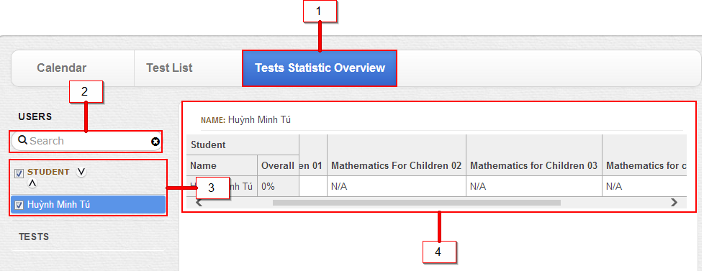

Step 1: Click on Test statistic Overview Tab (1)

Step 2: Search student for involving a student to statistic or not (2)

Step 3: make a check to particular student for involving a student to statistic or not (3)

Step 4: See the Overview of one or many student (4)

Step 5: (Search or make a Check to the test for involving a test to statistic or not)

: 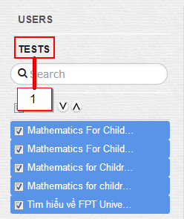

# Teacher’s Guide

## Create Test

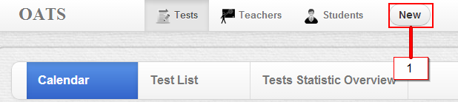

Figure : Create Test - step 1

Step 1: Login

Step 2: At index page, (default at Test “Tab”), Click button “New” (1)

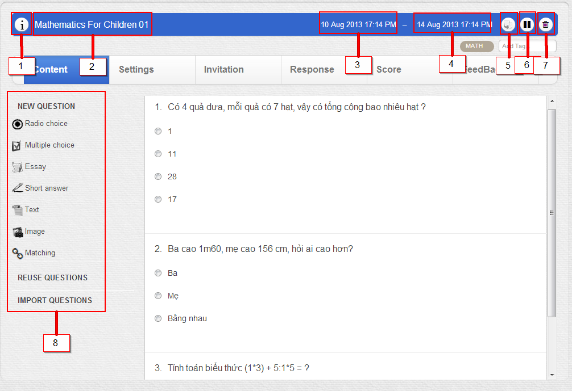

Figure : Create Test - step 2

Step 3: Click on (1) for short description.

Step 4: Enter test name (2)

Step 5: Enter start date (3)

Step 6: Enter end date (4)

Step 7: Click on the question type, or drag and drop to the next right zone for import question, then enter the question, and answer. (8)

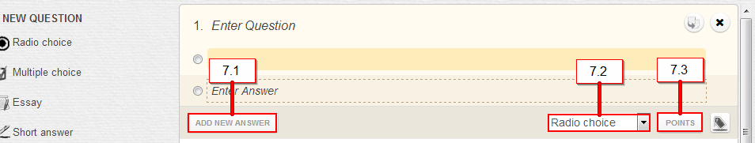

Figure : Create Test - step 3

More detail: add new answer (7.1), change question type (7.2) and add point to each answer (7.3)

**Notice:** Duplicate this test (5), Disable test (6), Delete test (7)

## Student’s Guide